**IV Sem Btech IT (Even 2023) IT252 Database Systems Lab Assignment - 2**

**Date: 17/05/2023(Wednesday) Marks : 30Marks (each question carries 10Marks)**

**Time: 1:00 to 2:00PM**

**1) Write a PL/SQL procedure called MULTI_TABLE that takes two numbers as parameter and displays the multiplication of the first parameter till the second parameter.**

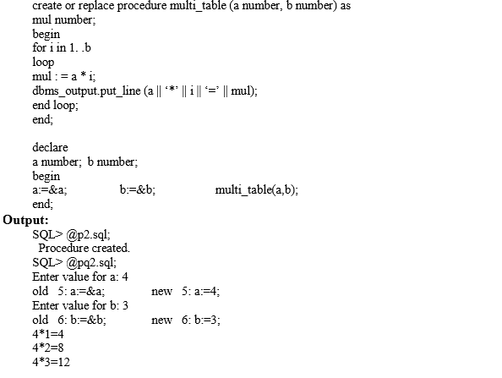

**2) Write a PL/SQL function ODDEVEN to return value TRUE if the number passed to it is EVEN else will return FALSE.**

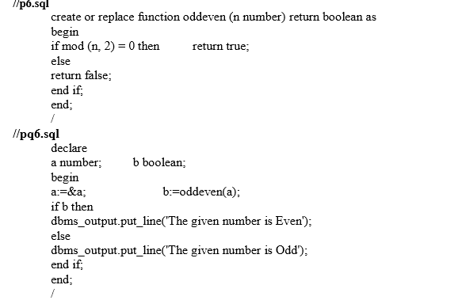

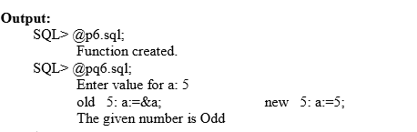

**3) Write a PL/SQL block that will display the name, dept no, salary of fist highest paid employees.**

